Offering free

*(Social Emotional Foundations for Early Learners)*

SEFEL  
Training for Parents!



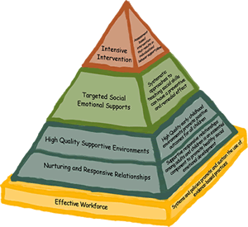

This training has changed my life in such a short amount of time! It has given me the tools to make a positive impact on my child’s negative behaviors and has given me the opportunity to create positive change from the negative. It is amazing and highly recommended for all parents! –Tracy Starr

This training was wonderful because it gave me a toolbox of resources I can use to help my daughter as she grows. They gave me multiple ideas/skills I can try. –Lisa Gottman

Social Emotional Foundations for Early Learning

**SEFEL Parent Training**

Prince George’s County Public Schools Early Childhood Program

would like to invite parents and care givers of young children (ages 2-5 years old) to

“Positive Solutions for Families”

Promoting Social and Emotional Competence in Young Children with Challenging Behaviors

The **3** session training will be held:

**Tuesday, March 3, 2020**

**Tuesday, March 10, 2020**

**Tuesday, March 17, 2020**

From

**6:00 PM - 8:00 PM**

Note: This training will be offered through three, two-hour sessions over three consecutive weeks. Although you are welcomed to attend individual sessions, it is best to attend all three sessions as the information in each session builds on the information presented in previous sessions.

Location:

Prince George’s Child Resource Center

9475 Lottsford Road, Ste. 202

Upper Marlboro, MD 20774

For questions and/or to register for the training, please email

Viviette Christian ([viviette.christian@pgcps.org](mailto:viviette.christian@pgcps.org)). When registering via email, please include the following information: your name, your email, your contact number, age(s) of the child(ren) in your care, school(s) your child(ren) attend(s), number of children who will be attending, if an interpreter is needed, and, if so, for what language**. Please register prior to March 3rd.** A minimum of eight people to need to be registered for the training to proceed.

***Childcare will be provided.***

Anyone who requires an auxiliary aide/service for effective communication, or the modification of a procedure/policy in order to participate in a school system sponsored program/service/activity should contact the school principal, individual or organization hosting the event, or the PGCPS ADA Compliance Officer. Requests should be made as soon as possible, but not later than 48 hours before the scheduled event.

______________________________________________________________________________