Bylaws of the Maryland Pyramid Model State Leadership Team (SLT)
Ratified on 1/9/2024

Article I Name and Purpose
Name: The Maryland Pyramid Model State Leadership Team, hereafter referred to as the SLT.
Purpose:
The Mission of the Maryland Pyramid Model State Leadership Team (SLT) is to develop, evaluate and sustain a statewide collaborative effort, guided by national models, that supports the local implementation of the Pyramid Model framework. This work is rooted in fidelity within a variety of early childhood programs and settings across communities within the state. We are committed to actualizing this work with deep intentionality around addressing equity and the needs of BIPOC students, educators, families and communities as referenced in our Equity Statement.

The Vision of the Maryland Pyramid Model State Leadership Team (SLT) is for families in partnership with the early childhood workforce to have the ability to equitably nurture and support infants' and young children's social emotional development and well-being within their diverse family cultures and communities to foster lifelong success. This can be accomplished through integration of the Pyramid Model with other related promotion, prevention, intervention, and treatment efforts in the state.

Equity Statement for the Maryland Pyramid Model State Leadership Team (SLT)
In recognition of the historical, systemic and current racial inequities that exist throughout all levels and layers of our society, we acknowledge that our youngest citizens are too often exposed and harmed. We know this delivers a lasting impact on their social and academic trajectories, the most detrimental of which are higher rates of suspension and expulsion among young black, indigenous, and people of color (BIPOC) before they enter kindergarten, which begins the preschool to prison pipeline. We believe that practices that promote social and emotional awareness and skills in both children and adults, like the Pyramid Model, can serve to significantly correct and address these realities. Recognizing this, the Maryland Pyramid Model SLT commits to implementing the Pyramid Model through a culturally responsive and anti-racist lens. In an effort to move this work forward, we are currently focusing on the following action items, and articulate them here to hold ourselves accountable:
- Implementation of a subcommittee dedicated to elevating equity that meets regularly and supports activities of the full SLT, with specific review of goals and accomplishments during the annual review of the Benchmark of Quality (BOQ).
- Ongoing review and adaptation of training and coaching curriculum to increase the equity lens within Maryland Pyramid Model efforts.
- Adding diversity, equity and inclusion measures into the BOQ fidelity items.
- Ongoing intention of adding and elevating the voices and perspectives of BIPOC partners involved in Pyramid Model efforts across the state.

Article II Members and Membership Criteria
All SLT Executive Committee meetings are open to the general public and advertised on the Maryland Pyramid Model website. To be a voting member of the group, you must meet the following criteria: commit to attend 75% of meetings (3 out of 4 quarterly meetings), in person or virtually, or send a representative of their choosing from their organization; and make a commitment to actively participate in Pyramid Model activities, including dissemination of SLT meeting information, sharing of Pyramid Model activities at quarterly meetings, and attend at least one Pyramid Model event per year to stay up-to-date with the latest information. In addition, members must recommit to the SLT each year by signing the annual commitment letter. Any new and/or visiting members should declare the intent of their participation (i.e. just visiting, interested in becoming a voting member, etc.).
Voting members of the SLT should be representative of the diverse workforce serving children from birth to second grade. The following organizations and areas of concentration could be represented on the SLT:
- State Systems/Administration
  - E.g. MSDE, BHA, MDH
- School Systems (from diverse regions to represent the full state’s geography and population)
- Early Intervention Programs
- Jurisdiction Level Government
- NGO/Nonprofits/Philanthropic Organizations
- Judy Centers/Child Resource Centers (from diverse regions to represent the full state’s geography and population)
- Pyramid Model Master Cadre Members
- Family Voice
- Child Care Providers & Teachers
- Early Head Start and Head Start Representation
- Higher Education
- Early Intervention Providers

New Member Additions:
Each year, there will be an annual review of membership to see who is maintaining voting member status and if there are any gaps in representation. After this analysis, invitations will be sent to include new members that the SLT has voted as appropriate additions and to confirm commitment of existing members who have not maintained voting membership status. New members will be asked to participate in a one-on-one meeting with the SLT Staffing and Management team either prior to attending their first SLT meeting, or shortly after their first few SLT meetings. This meeting will be an opportunity for new members to ask questions and get oriented to the team. Documents such as the bylaws and mission, vision and equity statements would be shared with individuals at this meeting as well. New members will also learn about the structure of the subcommittees and opportunities for them to engage in those additional meetings and activities during this meeting as well.
Article III Meetings Procedures and Guidelines
SLT Executive Committee Meetings will be held quarterly with a maximum time of two-hour meetings. Meetings will be called to order when at least 8-10 members are in attendance, allowing for both in-person and virtual participation. Once per year, the SLT will conduct an annual review of the State Leadership Team Benchmarks of Quality (BOQ) through holding a several-hour retreat in December or January. This analysis and related priorities discussion will inform the development of a yearly action plan which will inform meeting agendas. General meeting structure for the SLT Executive Committee will include an introduction and review of meeting agenda/objectives, ratification of previous meetings minutes, new business – including action plan items, organization updates, and evaluation and preparation for the next meeting. The meeting structure will be reviewed yearly and evaluated for its effectiveness.
All decisions will require 75% majority vote, based on the number of voting members in attendance at the meeting, to become ratified. There will be advance notice when a vote will occur to insure maximum attendance at the meeting. All votes will be motioned and seconded.
In addition to the SLT Executive Committee, members are invited to engage in a subcommittee, each of which focuses on a given component of the BOQ. They are outlined below, and all participation is encouraged, and allows SLT members to contribute their given expertise to our collective work, but subcommittee membership is not a requirement for Executive Committee members. Subcommittees meet once per month, and quarterly SLT Executive Committee meetings will be extended by ½ an hour to allow for report-outs of each subcommittee.
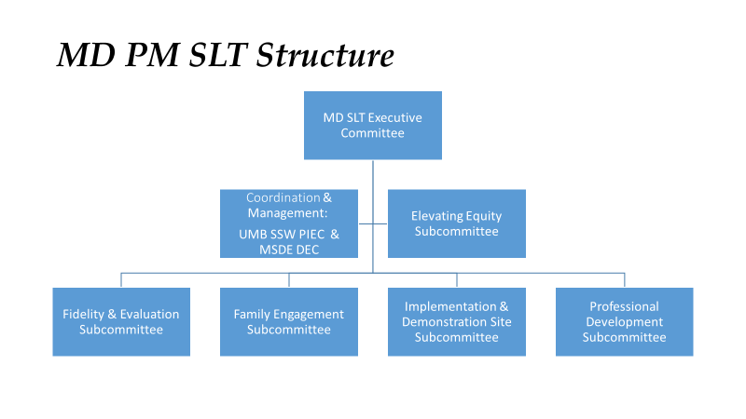
Article IV Amendments to the Bylaws
Each year, in conjunction with the review of the BOQ and membership, there will be a review of the Bylaws to see if any changes are necessary. During this time, voting members can motion for changes to the bylaws that will be discussed and voted upon.

